Task on Bash script:

=======================

1. Create on Bash script to check if a directory is available or not.

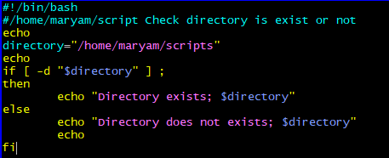

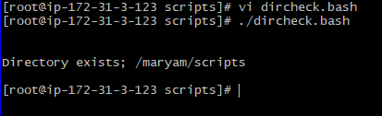

1. Create a bash script which will create multiple files.

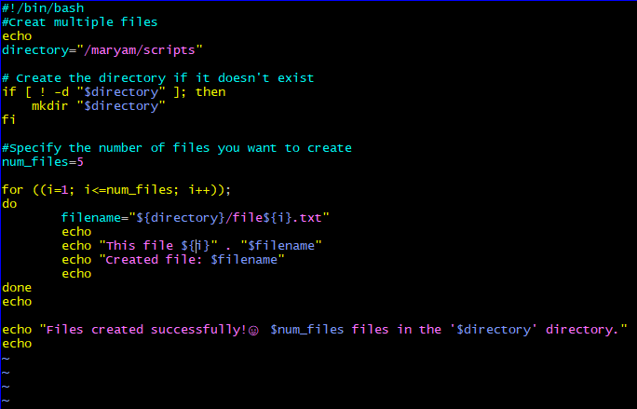

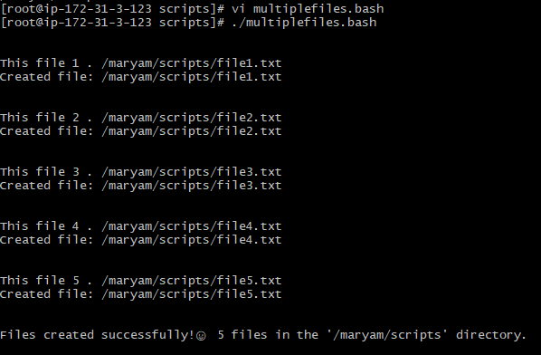

1. Create a bash script to take backup of a directory.

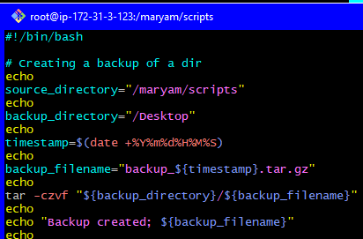

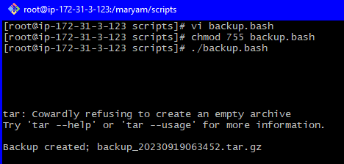

4) Create a bash script to install nginx in ec2 server.

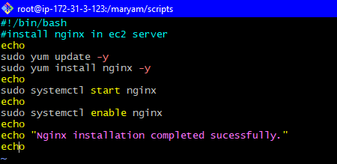

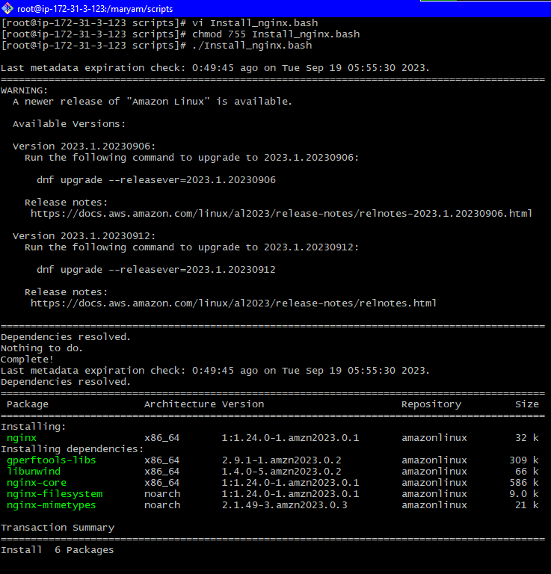

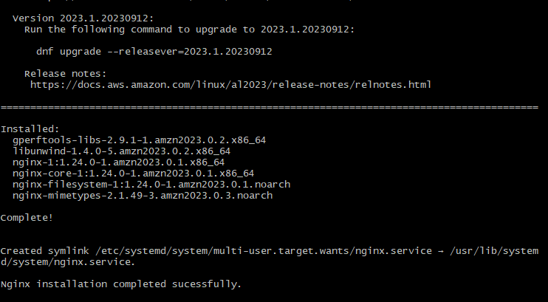

1. Create a bash script to install ApacheTomcat in ec2 server.

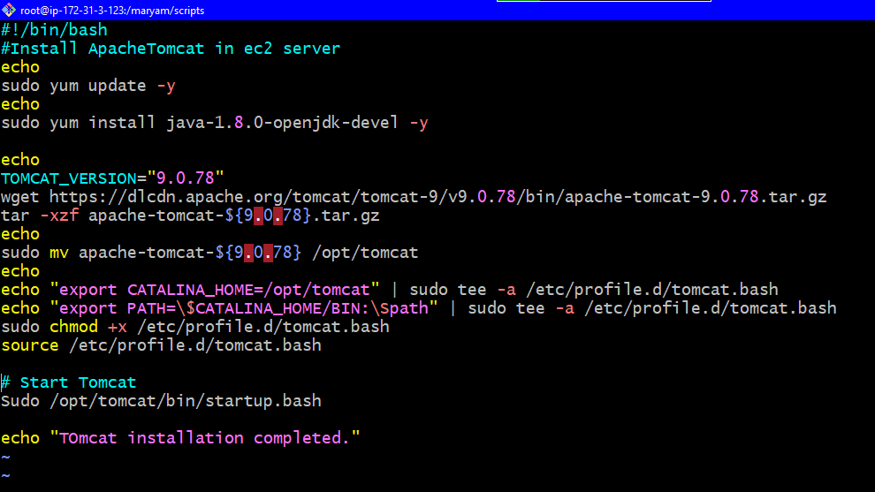

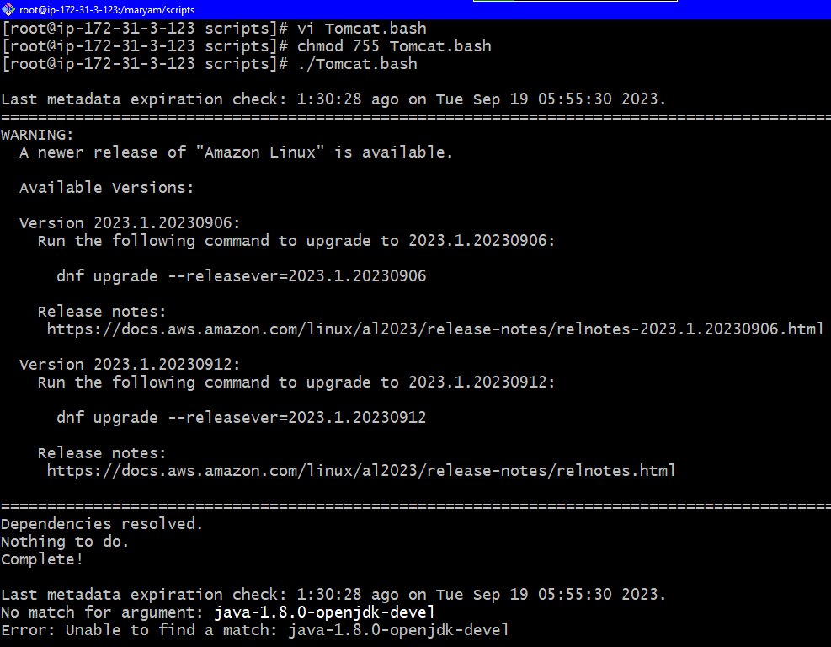

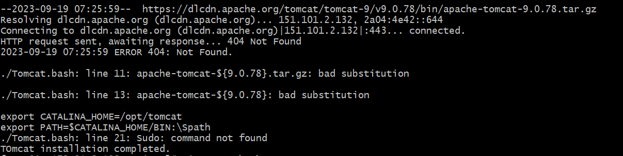

6) Create a bash script to check list if nginx service is running or not,if not running

then script should start the service.

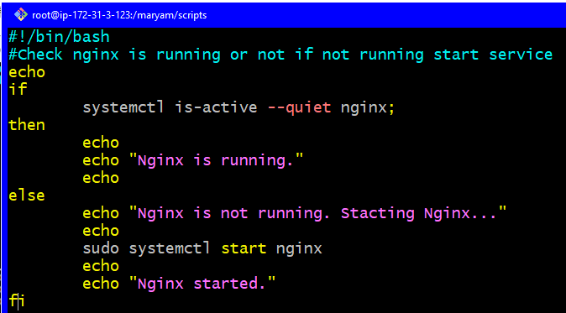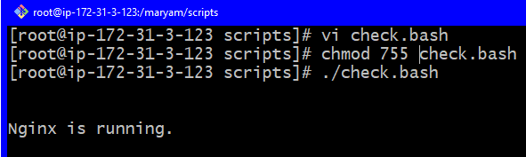

6)Create a bash script for calculator.

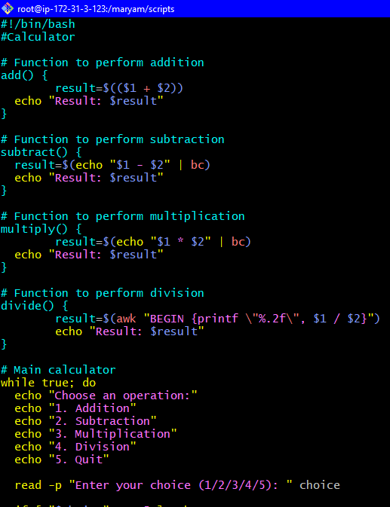

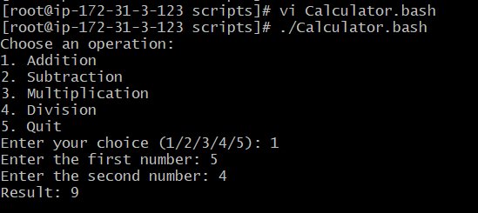

8) Create a bash script to check if directory is avaialble or not,if not then create a directory.

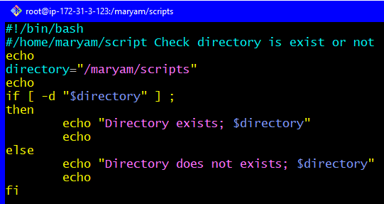 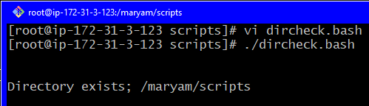

9) Create bash script to delete last 3 lines for a file.

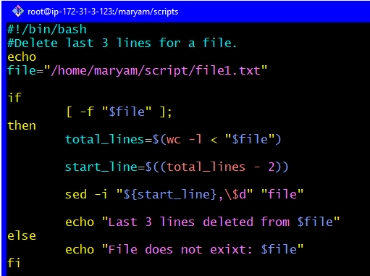

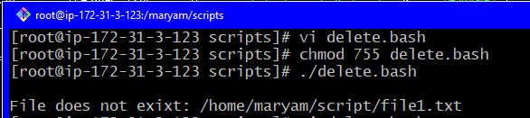

Exercise Crontab Entries:

1. April 5th Midnight

2) 5th of Every November, Jan, June if it is a Thursday.

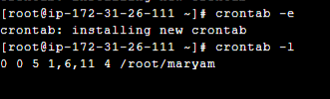

3)At 05 and 27th minutes of 9,10,11 hours every day.

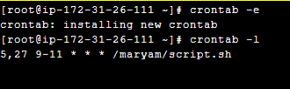

1. 15th second of 34 min. of 9th hour on 15th Aug.

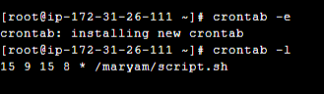

1. Every midnight

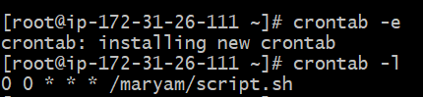

1. Every Weekend (Saturday night 11.59) 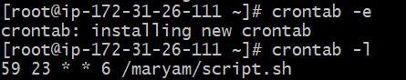
2. After every reboot

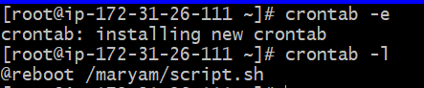

Note:

1) All the Scripts needs to be executed on Amazon Linux Ec2.

2) Document all the task and also push the task to GitHub repository.

3) Share the document and GitHub Repo URL once done for evaluation in

dvps-cloud-status channel.